First, download RubyInstaller Devkit from <https://rubyinstaller.org/downloads/>

The version we downloaded is Ruby + Devkit 3.3 x64

The full step tutorial for Windows is here <https://jekyllrb.com/docs/installation/windows/>

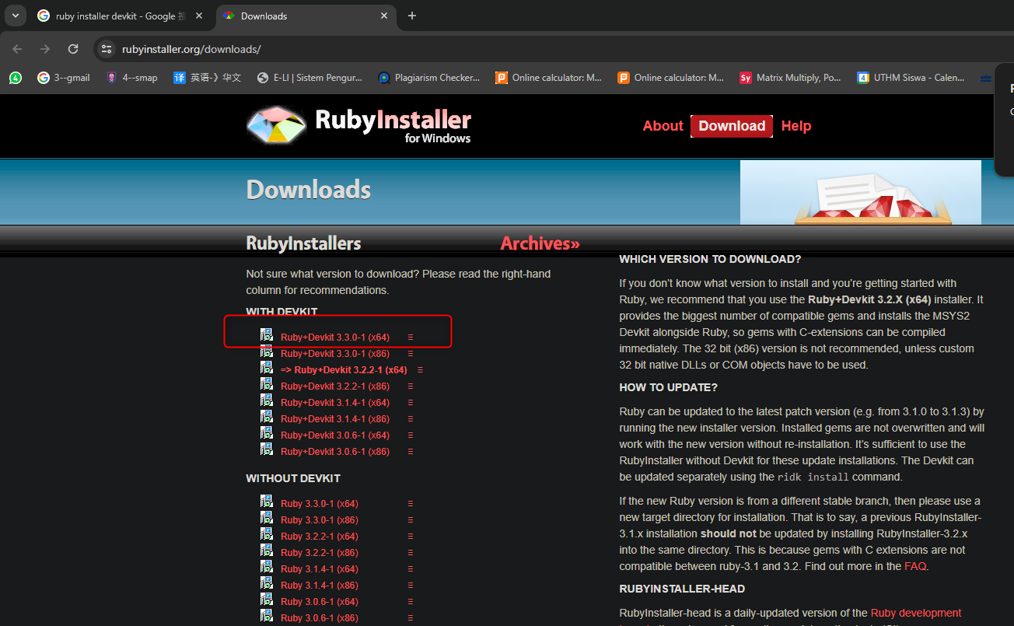

The thing we require to install in the Ruby Installer is MSYS2 and MINGW development tool chain

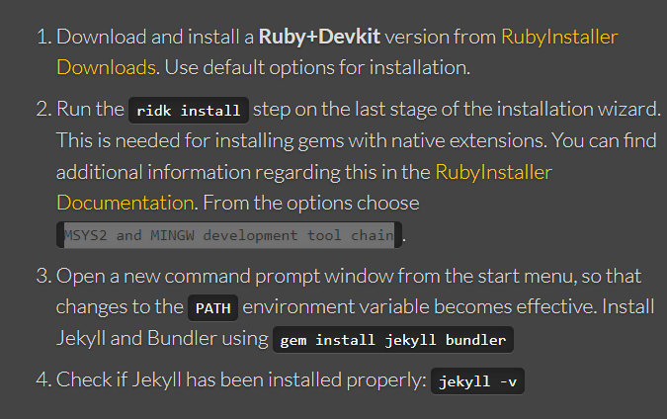

It is at the last step of the in installer, the option is 3

After we have installed the Ruby installer , we create a empty folder, in this case we named it ‘TestJekyll’

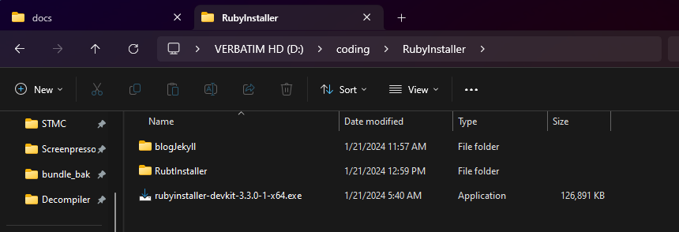

|  |
| --- |
| D:\coding\RubyInstaller\blogJekyll\CodingBlog\docs>cd ./TestJekyll |

We create it with the command

|  |
| --- |
| D:\coding\RubyInstaller\blogJekyll\CodingBlog\docs\TestJekyll>jekyll new --skip-bundle . |
| New jekyll site installed in D:/coding/RubyInstaller/blogJekyll/CodingBlog/docs/TestJekyll.  Bundle install skipped. |

And then bundle install

|  |
| --- |
| D:\coding\RubyInstaller\blogJekyll\CodingBlog\docs\TestJekyll>bundle install |
| Fetching gem metadata from https://rubygems.org/............  Resolving dependencies...  Fetching jekyll-feed 0.17.0  Installing jekyll-feed 0.17.0  Bundle complete! 7 Gemfile dependencies, 36 gems now installed.  Use `bundle info [gemname]` to see where a bundled gem is installed.  D:\coding\RubyInstaller\blogJekyll\CodingBlog\docs\TestJekyll>bundle exec jekyll server  D:/coding/RubyInstaller/RubtInstaller/lib/ruby/gems/3.3.0/gems/jekyll-4.3.3/lib/jekyll.rb:28: warning: csv was loaded from the standard library, but will no longer be part of the default gems since Ruby 3.4.0. Add csv to your Gemfile or gemspec. Also contact author of jekyll-4.3.3 to add csv into its gemspec.  D:/coding/RubyInstaller/RubtInstaller/lib/ruby/gems/3.3.0/gems/safe_yaml-1.0.5/lib/safe_yaml/transform.rb:1: warning: base64 was loaded from the standard library, but will no longer be part of the default gems since Ruby 3.4.0. Add base64 to your Gemfile or gemspec. Also contact author of safe_yaml-1.0.5 to add base64 into its gemspec.  D:/coding/RubyInstaller/RubtInstaller/lib/ruby/gems/3.3.0/gems/liquid-4.0.4/lib/liquid/standardfilters.rb:2: warning: bigdecimal was loaded from the standard library, but will no longer be part of the default gems since Ruby 3.4.0. Add bigdecimal to your Gemfile or gemspec. Also contact author of liquid-4.0.4 to add bigdecimal into its gemspec.  Configuration file: D:/coding/RubyInstaller/blogJekyll/CodingBlog/docs/TestJekyll/_config.yml  Source: D:/coding/RubyInstaller/blogJekyll/CodingBlog/docs/TestJekyll  Destination: D:/coding/RubyInstaller/blogJekyll/CodingBlog/docs/TestJekyll/_site  Incremental build: disabled. Enable with --incremental  Generating...  Jekyll Feed: Generating feed for posts  Deprecation Warning: Using / for division outside of calc() is deprecated and will be removed in Dart Sass 2.0.0.  Recommendation: math.div($spacing-unit, 2) or calc($spacing-unit / 2)  More info and automated migrator: https://sass-lang.com/d/slash-div  /*  Bunch of errors here  */  More info and automated migrator: https://sass-lang.com/d/slash-div  ╷  244 │ padding: ($spacing-unit / 3) ($spacing-unit / 2);  │ ^^^^^^^^^^^^^^^^^  ╵  ..\..\..\..\minima-2.5.1\_sass\minima\_base.scss 244:15 @import  minima.scss 48:3 @import  D:\coding\RubyInstaller\blogJekyll\CodingBlog\docs\TestJekyll\assets\main.scss 1:9 root stylesheet  Warning: 6 repetitive deprecation warnings omitted.  Run in verbose mode to see all warnings.  done in 3.163 seconds.  Auto-regeneration: enabled for 'D:/coding/RubyInstaller/blogJekyll/CodingBlog/docs/TestJekyll'  Server address: http://127.0.0.1:4000/  Server running... press ctrl-c to stop. |

We can start the host service with the command

|  |
| --- |
| D:\coding\RubyInstaller\blogJekyll\CodingBlog\docs\TestJekyll>bundle exec jekyll serve |
| D:/coding/RubyInstaller/RubtInstaller/lib/ruby/gems/3.3.0/gems/jekyll-4.3.3/lib/jekyll.rb:28: warning: csv was loaded from the standard library, but will no longer be part of the default gems since Ruby 3.4.0. Add csv to your Gemfile or gemspec. Also contact author of jekyll-4.3.3 to add csv into its gemspec.  D:/coding/RubyInstaller/RubtInstaller/lib/ruby/gems/3.3.0/gems/safe_yaml-1.0.5/lib/safe_yaml/transform.rb:1: warning: base64 was loaded from the standard library, but will no longer be part of the default gems since Ruby 3.4.0. Add base64 to your Gemfile or gemspec. Also contact author of safe_yaml-1.0.5 to add base64 into its gemspec.  D:/coding/RubyInstaller/RubtInstaller/lib/ruby/gems/3.3.0/gems/liquid-4.0.4/lib/liquid/standardfilters.rb:2: warning: bigdecimal was loaded from the standard library, but will no longer be part of the default gems since Ruby 3.4.0. Add bigdecimal to your Gemfile or gemspec. Also contact author of liquid-4.0.4 to add bigdecimal into its gemspec.  Configuration file: D:/coding/RubyInstaller/blogJekyll/CodingBlog/docs/TestJekyll/_config.yml  Source: D:/coding/RubyInstaller/blogJekyll/CodingBlog/docs/TestJekyll  Destination: D:/coding/RubyInstaller/blogJekyll/CodingBlog/docs/TestJekyll/_site  Incremental build: disabled. Enable with --incremental  Generating...  Jekyll Feed: Generating feed for posts  Deprecation Warning: Using / for division outside of calc() is deprecated and will be removed in Dart Sass 2.0.0.  Recommendation: math.div($spacing-unit, 2) or calc($spacing-unit / 2)  More info and automated migrator: https://sass-lang.com/d/slash-div  /*  Bunch of errors here too  */  ..\..\..\..\minima-2.5.1\_sass\minima\_base.scss 244:15 @import  minima.scss 48:3 @import  D:\coding\RubyInstaller\blogJekyll\CodingBlog\docs\TestJekyll\assets\main.scss 1:9 root stylesheet  Warning: 6 repetitive deprecation warnings omitted.  Run in verbose mode to see all warnings.  done in 0.737 seconds.  Auto-regeneration: enabled for 'D:/coding/RubyInstaller/blogJekyll/CodingBlog/docs/TestJekyll'  Server address: http://127.0.0.1:4000/  Server running... press ctrl-c to stop.  [2024-01-21 13:08:49] ERROR `/favicon.ico' not found. |

The default localhost is <http://127.0.0.1:4000>, the sreen of index page as below

